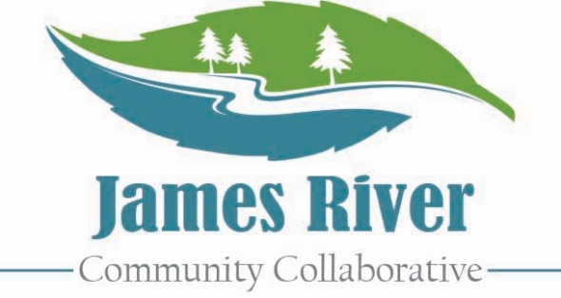

7th Annual Summer Training Conference

**Request For Proposal**

**Proposal Deadline is May 30, 2025**

**What is JRCC?**

The James River Community Collaborative is a diverse group of professionals and community members passionate about providing opportunities for community resource sharing, networking, and training.

**About the Training Conference**

The James River Community Collaborative will host their Annual Summer Training Conference on June 27, 2025 at Linkhorne Middle School in Lynchburg, VA. This event attracts 300+ professionals working with children and adults throughout the system of care. JRCC is seeking proposals to provide 1 hour training sessions that support the professionals in our community. Attendance in each training session varies, but can be up to 40 people. Presentations should relate to System of Care professionals working to build resiliency with families and children. **All proposals are due by May 30, 2025.**

**Sample Topics of Interest**

* Self-care / burnout prevention
* Trauma (specialized topics)
* Family engagement
* Foster care
* Adult MH / SA services
* Legal and court issues
* Domestic violence
* Health and wellness
* Substance abuse
* Non-traditional therapies
* ID / DD services or information
* Leadership / professional
* Housing
* Classroom management

**Submit the attached form to:**

info@jamesrivercommunitycollaborative.com



8th Annual Summer Training Conference

**Request For Proposal**

**Proposal Deadline is May 30, 2025**

**Presentation Title:** _____________________________________________________________________

**Coordinator of Presentation:** _____________________________________________________________

**Title:** _________________________________ **Organization:** __________________________________  
**Phone:** _______________________________ **Email:** ________________________________________

**Additional Presenters:** __________________________________________________________________

**Please check equipment that you would like JRCC to provide for you:**

☐Laptop ☐Projector ☐Screen ☐Flip Chart ☐Internet

☐Adaptor Cable: List type________________ ☐Other accommodations:__________________________

**Brief Bio of Presenters***Brief description. Will be used for conference materials.*

**Presentation Description***Brief Description. Will be used for conference materials.*

**Learning Objectives & Training Outline***Please indicate what attendees can expect to take away from your workshop.*

**Presentation Length** ☐One session (75 minutes) ☐Two sessions (150 minutes)

**Are you willing to present more than one session?** ☐Yes ☐No

**Submit to info@jamesrivercommunitycollaborative.com by May 30, 2025**