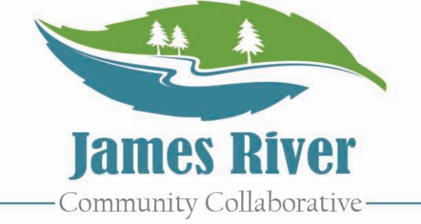
4th Annual Summer Training Conference

Request For Proposal

Proposal Deadline is January 31, 2020
What is JRCC?
The James River Community Collaborative is a diverse group of professionals and community members passionate about providing opportunities for community resource sharing, networking, and training.

About the Training Conference
The James River Community Collaborative will host their Annual Summer Training Conference on June 12, 2020 at Heritage High School in Lynchburg, VA. This event attracts 300+ professionals working with children and adults throughout the system of care. JRCC is seeking proposals to provide 1 hour training sessions that support the professionals in our community. Attendance in each training session varies, but can be up to 40 people. Presentations should relate to System of Care professionals working to build resiliency with families and children. All proposals are due by January 31, 2020. Proposal acceptances will be sent out by February 10, 2020.

Sample Topics of Interest

- Self-care / burnout prevention
- Trauma-informed care
- Family engagement
- Foster care
- Art therapy
- Legal and court issues
- Domestic violence
- Health and wellness
- Substance abuse
- System of care
- Community based services
- Leadership / professional
- Housing
- Classroom management

Submit the attached form to:
info@jamesrivercommunitycollaborative.com

4th Annual Summer Training Conference

Request For Proposal

Proposal Deadline is January 31, 2020

Presentation Title: _____________________________________________________________________
Coordinator of Presentation: _____________________________________________________________
Title: _________________________________ Organization: __________________________________
Phone: _______________________________ Email: ________________________________________
Additional Presenters: __________________________________________________________________
Brief Bio of Presenters
Brief description. May be used for conference materials.

Presentation Description
Brief Description. May be used for conference materials.

Learning Objectives & Training Outline
Please indicate what attendees can expect to take away from your workshop.

Submit to info@jamesrivercommunitycollaborative.com by January 31, 2020

